**Name – Pranit Tandon**

**Reg no - RA1911028010014**

**AIM:-** TO Implement HDLC configuration using Cisco Packet Tracer

**Component Used**:-

|  |  |  |
| --- | --- | --- |
| Device | Type | Quantity |
| Device | Laptop | 2 |
| Router | 1841 | 2 |
| Wires | Serial DCE  Console | - |

**Circuit Diagram**

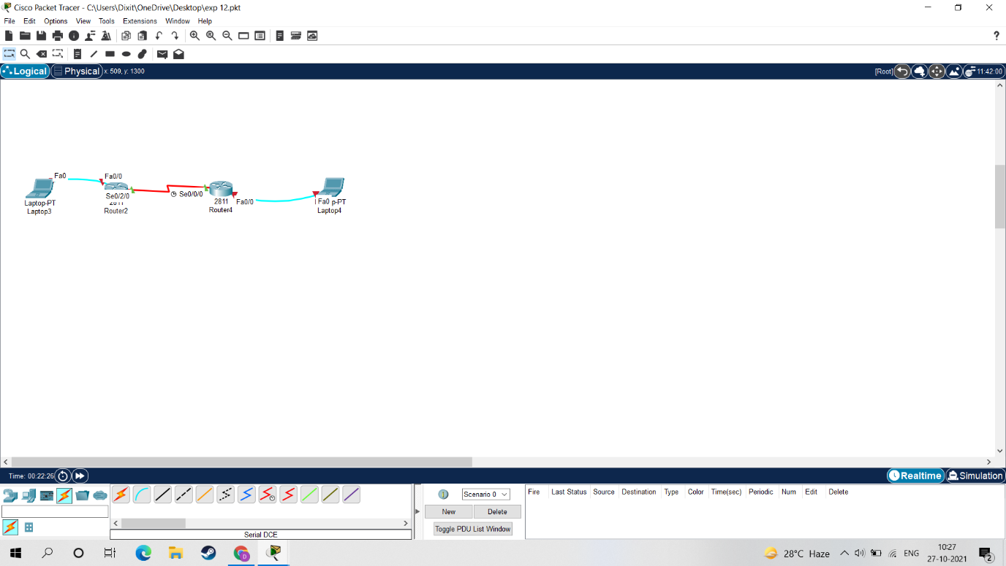

**Ping Command**

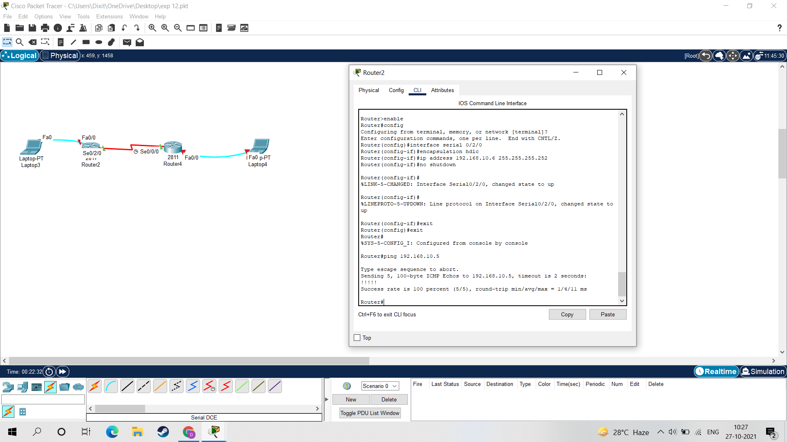

**Result:-**

Thus, HDLC configuration is implemented and verified by using ping command